Assessment for Unit 5 Period: ______ Name: _______________________________________

Part 1. Identify each figure. List the number of faces, edges, and vertices.
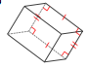 | 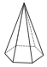 | 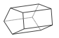 | 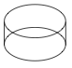
Name: ______________________  ______________________________  Faces: ______________________  Edges: ______________________  Vertices: ___________________ | Name: ______________________  ______________________________  Faces: ______________________  Edges: ______________________  Vertices: ___________________ | Name: ______________________  ______________________________  Faces: ______________________  Edges: ______________________  Vertices: ___________________ | Name: ______________________  ______________________________  Faces: ______________________  Edges: ______________________  Vertices: ___________________
Part 2. Determine both the PERIMETER and the AREA of the figures.
 |  | 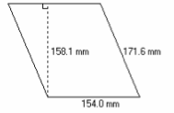
PERIMETER: |  | PERIMETER:
AREA: |  | AREA:
Unit 5, Assessment Page 1
Part 3. Describe how PERIMETER and AREA are related:

Part 4. Determine both the SURFACE AREA and the VOLUME of the figures.
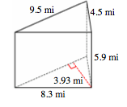 |  | 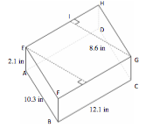
SURFACE AREA: |  | SURFACE AREA:
VOLUME: |  | VOLUME:
Part 5. Describe how SURFACE AREA and VOLUME are related:
Unit 5, Assessment Page 2
Assessment for Unit 5 Period: ______ Name: _______________________________________
Part 6. Candy Bar Madness.

A 4th grader is selling candy bars for a class fundraiser. He needs to walk around and sell these candy bars in his neighborhood. He decides to place the candy bars in a box to carry them around with ease. In his closet he finds a shoe box that is 11 1/2 inches x 6 inches x 4 1/8 inches. Help this 4th grader by determining how many candy bars he can fit comfortably in the box, without cramming or overflowing.

Note: The candy bars are 4 inches x .75 inches x 1 inch
Unit 5, Assessment Page 3
Part 7. John's Field.

John has decided to fix up an old field for his son’s horse. The length of the field is 10 meters less than 4 times its width. First, he fenced in the field at a cost of $4.80 per meter. The total cost was $1,584. He now needs to buy sweetgrass seed to plant in the field. The seed costs $3.98 per bag and covers 460 square meters.

How much money will John have invested in this field?
Unit 5, Assessment Page 4
Assessment Rubric for Unit 5 Name: ___________KEY 160 pts possible____________

Part 1. Identify each figure. List the number of faces, edges, and vertices.
1 pt for each correct answer. (16 pts. possible)
Name: rectangular prism  Faces: 6  Edges: 8  Vertices: 8 | Name: hexagonal pyramid  Faces: 7  Edges: 12  Vertices: 7 | Name: pentagonal prism  Faces: 7  Edges: 15  Vertices: 10 | Name: cylinder  Faces: 3  Edges: 2  Vertices: 0
Part 2. Determine both the PERIMETER and the AREA of the figures. (32 pts. possible)
PERIMETER:  H (2 x 7) + B (2 x 8) = 30 units  2 pt = used one correct number (8 or 7).  4 pts = used two correct numbers (7 and 8).  6 pts = used correct formula [(2x7) + (2x8)] OR [7+7+8+8]  8 pts = used correct formula AND found correct answer. |  | PERIMETER:  (171.6 x 2) + (154 x 2) = 651.2 mm  2 pt = used one correct number (171.6 or 154).  4 pts = used two correct numbers (171.6 or 154).  6 pts = used correct formula [(171.6 x 2) + (154 x 2)] OR [171.6 + 171.6 + 154 + 154]  8 pts = used correct formula AND found correct answer.
AREA:  H 7 x B 8 = 56 units²  2 pt = used one correct number (8 or 7).  4 pts = used two correct numbers (7 and 8).  6 pts = used correct formula [7x8]  8 pts = used correct formula AND found correct answer. |  | AREA:  (158.1 x 154) = 24,347.4 mm²  2 pt = used one correct number (171.6 or 154).  4 pts = used two correct numbers (171.6 or 154).  6 pts = used correct formula  (158.1 x 154).  8 pts = used correct formula AND found correct answer.
Unit 5, Assessment Rubric Page 1
Part 3. Describe how PERIMETER and AREA are related: (8 pts. possible)
The base and height are added together for perimeter, while the base x height are multiplied for area. When dealing with a triangle or parallelogram, you use a hypotenuse for perimeter, but you still use the height for area.
2 pt = recognize addition for perimeter OR multiplication for area, but not both.
4 pt = recognize addition for perimeter AND multiplication for area.
6 pt = also include information for parallelogram/triangle.
8 pt = also include information for parallelogram/triangle AND differentiate between the use of height vs. hypotenuse.
Part 4. Determine both the SURFACE AREA and the VOLUME of the figures. (32 pts. possible)
SURFACE AREA:  (9.5 x 3.93) + (9.5 x 5.9) + (4.5 x 5.9) + (8.3 x 5.9) = 168.91 mi²  1 pt per correct numbered pair = ((9.5 x 3.93), (9.5 x 5.9), (4.5 x 5.9), (8.3 x 5.9)  5 pts = used correct number pairs AND correct formula  6 pts = used correct numbered pairs, formula, AND found correct answer. |  | SURFACE AREA:  (8.6 x 12.1 x 2) + (12.1 x 2.1 x 2) + (10.3 x 2.1 x 2) = 2185.5 in²  1 pt per correct numbered set = (8.6 x 12.1 x 2) + (12.1 x 2.1 x 2) + (10.3 x 2.1 x 2)  5 pts = used correct number sets AND correct formula  6 pts = used correct numbered sets, formula, AND found correct answer.
VOLUME:  (9.5 x 3.93 ÷ 2) x 5.9 = 110.14 mi³  1 pt per correct number = (9.5, 3.93, 5.9)  5 pts = used correct number pairs AND correct formula  6 pts = used correct numbers, formula, AND found correct answer. |  | VOLUME:  (8.6 x 12.1 x 2.1] = 218.52 in³  1 pt per correct number = (8.6 x 12.1 x 2.1)  5 pts = used correct numbers AND correct formula  6 pts = used correct numbers, formula, AND found correct answer.
Part 5. Describe how SURFACE AREA and VOLUME are related: (8 pts. possible)
The individual face areas are multiplied and then added for surface area, while the base x height x width are multiplied for volume. For triangle volume you divide the area in half before multiplying by the width.
2 pts = recognize multiplication and addition for surface area [(b x h) + (b x h) + (b x h) +…] OR multiplication for volume (b x h x w), but not both.
4 pt = recognize multiplication and addition for surface area AND multiplication for volume.
6 pt = also include information for triangle.
8 pt = also include information for parallelogram/triangle AND differentiate between the use of height vs. hypotenuse.
Unit 5, Assessment Rubric Page 2
Part 6. Volume - Candy Bar Madness. A 4th grader is selling candy bars for a class fundraiser. He needs to walk around and sell these candy bars in his neighborhood. He decides to place the candy bars in a box to carry them around with ease. In his closet he finds a shoe box that is 11 1/2 inches x 6 inches x 4 1/8 inches. Help this 4th grader by determining how many candy bars he can fit comfortably in the box, without cramming or overflowing.
Note: The candy bars are 4 inches x .75 inches x 1 inch
8 pts Novice: The Novice will have difficulty considering the three-dimensionality of the task and will be limited by the rudimentary diagram s/he creates to solve the problem. Little or no math language will be used, and little or no mathematical reasoning will be evidenced.
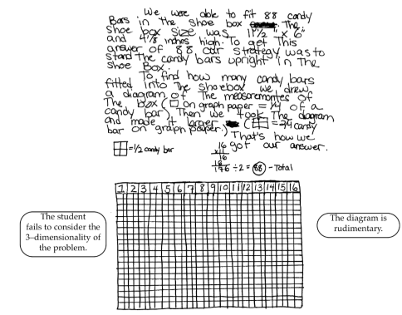
Unit 5, Assessment Rubric Page 3
16 pts Apprentice: The Apprentice will have an approach that will lead to solving part of the problem but will be challenged to spatially imagine the box and will not fill the box as completely as possible. Some math language will be used, but it may be incorrect. For instance, it is common for students to use the word “area” when they are determining volume. Math representations will more than likely be used as a strategy.
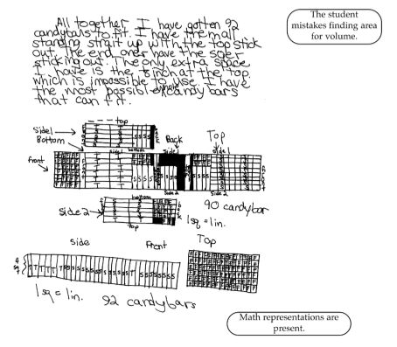

Unit 5, Assessment Rubric Page 4
24 pts. Practitioner: The Practitioner will have a mathematically correct solution. There will be labeled and accurate math representations to support the solution, and accurate and appropriate math language will be used throughout.
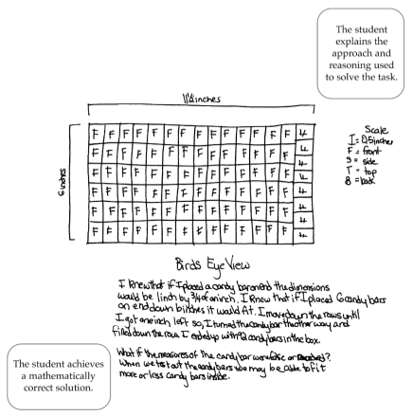

Unit 5, Assessment Rubric Page 5

32 pts. Expert: The Expert will have all of the characteristics of the Practitioner but will also have a clearly explained approach and reasoning. The Expert will use precise math language and will make mathematically relevant connections and observations.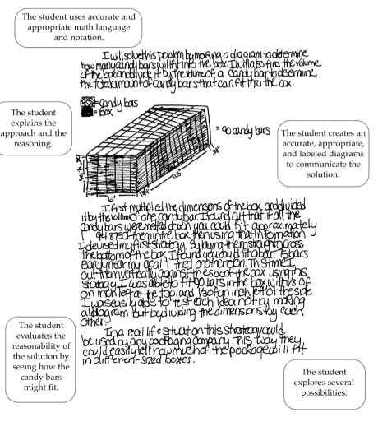
Unit 5, Assessment Rubric Page 6

Part 7. Perimeter & Area - John's Field. John has decided to fix up an old field for his son’s horse. The length of the field is 10 meters less than 4 times its width. First, he fenced in the field at a cost of $4.80 per meter. The total cost was $1,584. He now needs to buy sweetgrass seed to plant in the field. The seed costs $3.98 per bag and covers 460 square meters.
How much money will John have invested in this field?
8 pts. Novice: The Novice will be likely to find the sum of the dollar amounts given in the task ($1,584 + $4.80 + $3.98) and disregard the other information. Little math reasoning will be evident, and little math language will be used. | 16 pts. Apprentice: The Apprentice will have a strategy that works for part of the task but will not be able to follow through to successful completion. S/he may find the perimeter but then will divide that number by the area covered by each bag of seed, instead of finding the length, width and area of the field. Some math language will be used, and diagrams may be attempted.
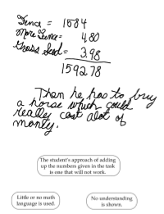 | 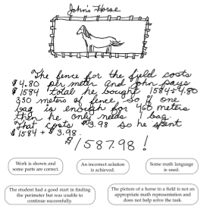
Unit 5, Assessment Rubric Page 7

24 pts. Practitioner: The Practitioner will have a strategy to solve all parts of the task, and the answers will be correct. S/he will use accurate and appropriate math language and representation. All work will be included, and it will be easy to follow the student's approach and reasoning.
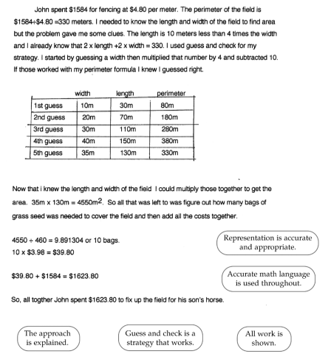

Unit 5, Assessment Rubric Page 8

32 pts. Expert: The Expert will have a strategy to solve all parts of the task, and the answer will be correct. S/he will probably use an algebraic equation to solve for the dimensions of the field. All math language and representations will be accurate and appropriate. The Expert will make a mathematically relevant connection.
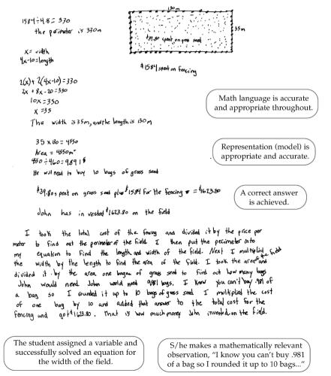

Unit 5, Assessment Rubric Page 9

Scoring Sheet for Assessment

Name: ______________________________________________Unit 5 – Geometry: 3-dimensional figures assessment
Total Score_______/160 |  |  | Points Possible / Earned
Sec | Obj | Assessment problem | 1 | 2 | 3 | 4 | 5 | 6 | 7
1 |  | Review 2D figures
 | 1 | Shape vocabulary
2 |  | 3D figure features
 | 1 | Feature vocabulary
 | 2 | Identify features | ¹⁶
3 |  | Perimeter, area, volume
 | 1 | Understand perimeter |  | ⁸ |  |  |  |  | ⁴
 | 2 | Compute perimeter |  | ⁸ |  |  |  |  | ⁴
 | 3 | Understand area |  | ⁸ |  |  |  |  | ⁴
 |  | Understand surface area |  |  |  | ⁸
 | 4 | Relate perimeter & area |  |  | ⁸
 | 5 | Compute area |  | ⁸ |  |  |  |  | ⁴
 |  | Compute surface area |  |  |  | ⁸
 | 6 | Understand volume |  |  |  | ⁸ |  | ⁸
 | 7 | Relate surface area & volume |  |  |  |  | ⁸
 | 8 | Compute volume |  |  |  | ⁸ |  | ⁸
 | 9 | Differentiate perimeter, area, vol |  |  |  |  |  | ⁸ | ⁸
 | 10 | Apply perimeter, area, vol |  |  |  |  |  | ⁸ | ⁸

