Erika Bradshaw
Thematic Unit – Lesson Plans
6TH Grade Math – Perimeter, Area, and Volume

Design plan for geometry: 3-dimensional figures
Overarching goal: Students will be able to compute perimeter, area, volume, and surface area; differentiate between the three, and apply them to real-life situations.

Cooperative Group Roles
Many of the activities included in this lesson plan include cooperative group work. When students are asked to work with task sheets, they will assume the cooperative roles. The instructor should rotate the roles for each subsequent group activity. (This does not include discussion strategies such as Think-Pair-Share, Round Robin, or Numbered Heads.) Role Cards can be placed on student’s desks for reference. For groups of less than six members, remove the reporter cards first (combine this task with the recorder) then remove the time keeper card second (combine this task with the materials manager).

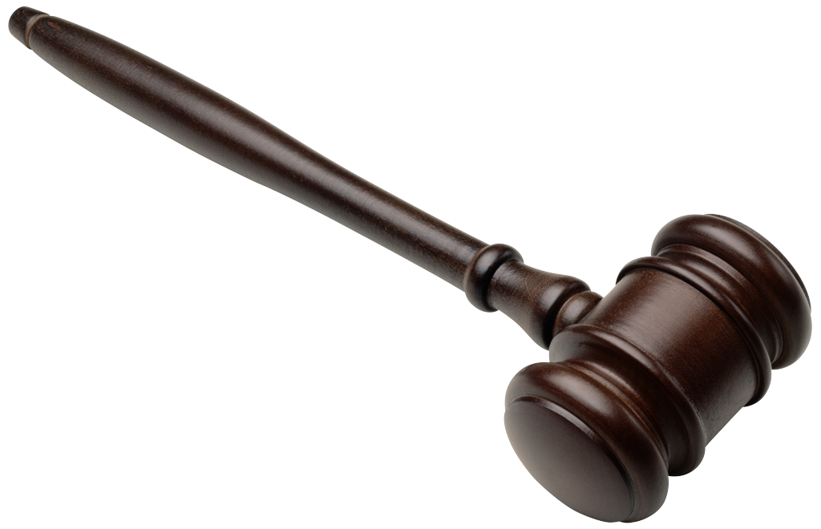  Role Card #1  Facilitator  Makes certain that everyone contributes and keeps the group on task. | 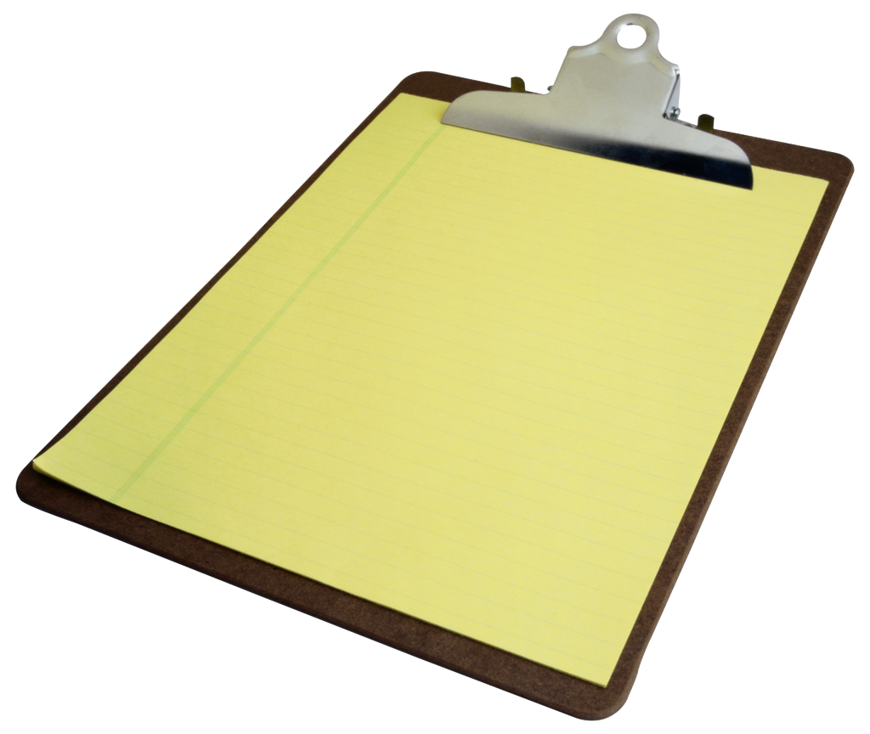  Role Card #2  Recorder  Keeps notes on important thoughts expressed in the group. Writes the final summary.
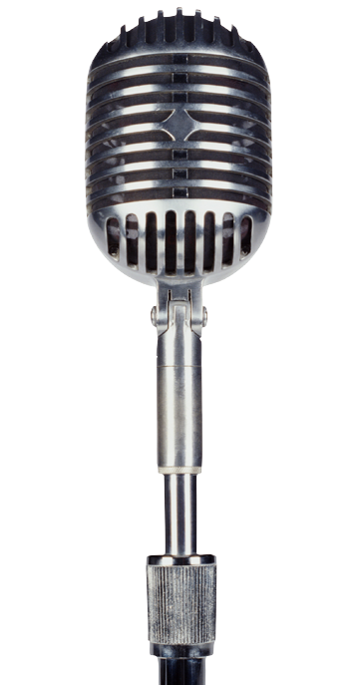  Role Card #3  Reporter  Shares summary of group with the larger group. Speaks for the group, not just a personal view. | Role Card #4  Materials  Manager  Picks up, distributes, collects, turns in, or puts away materials. Manages materials during group work.
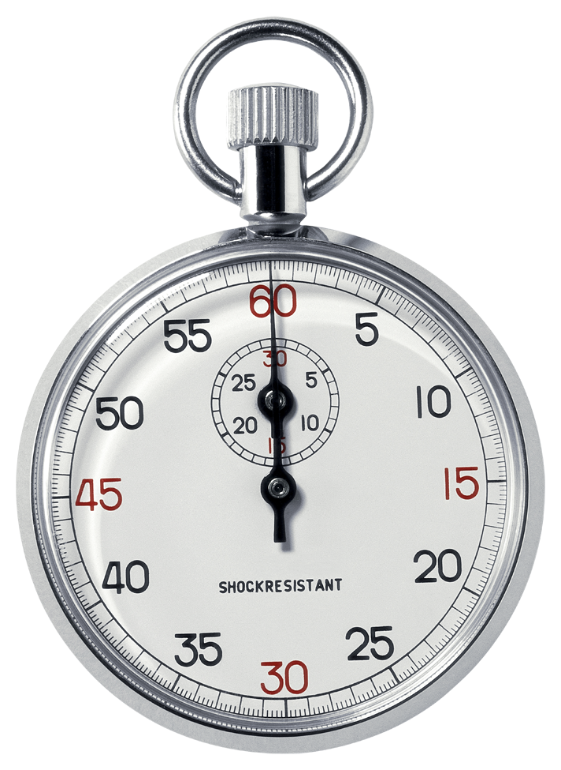  Role Card #5  Time Keeper  Keep track of time and reminds the group of how much time is left. | Role Card #6  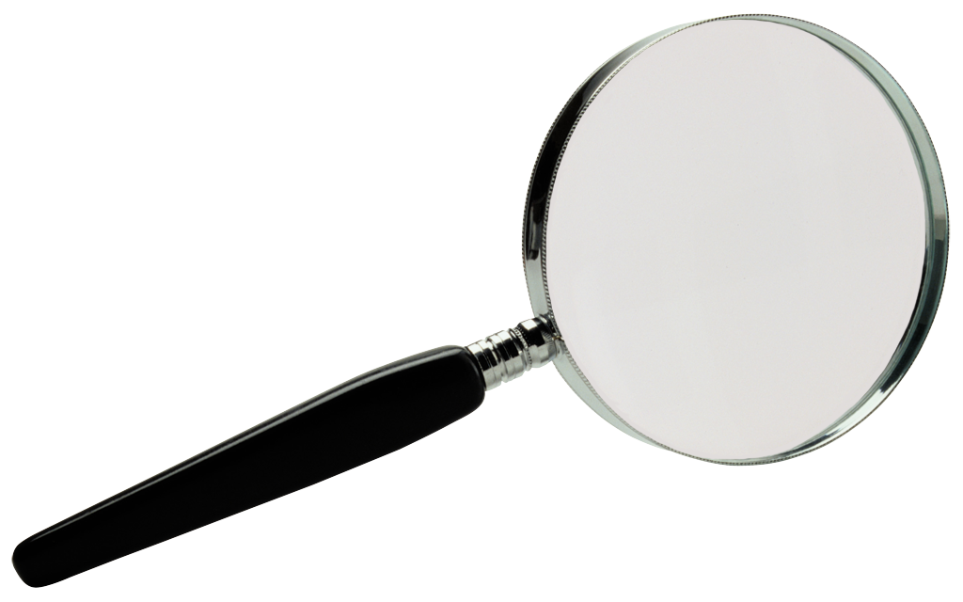  Checker  Checks for accuracy and clarity of thinking during discussions. May also check written work and keeps track of group point scores.

Lesson 3 - Area
Supplies |  | - Task sheet for area and perimeter.  - Scratch paper for practice.  - Textbook for homework assignment. (Foresman & Wesley, enVisionMath Grade 6)
Key |  | Objectives, Activities, & Procedure; Dialogue; Feedback, Evaluation, and Assessment
Obj | Time Mins | Objective 3: SWBAT understand area of 2-D figures and surface area of 3-D figures, limited to parallelograms and triangles using examples and non-examples.  Objective 4: SW discover-a-relationship between perimeter and area/surface area.  Lesson Type: Discover a relationship.
Gain Attn | 2 | - Repeat “Perimeter and Area” drill chorally.
Recall | 7 | - Say: In our previous lesson, we computed perimeter of different shapes.  - Say: Get out your homework and let’s correct it together. (p 427-428 #7-26 or the problems assigned).  - Students will correct their own homework for error analysis.  - Evaluation: The instructor will review later for error analysis.
Direction | 3 | - Say: Today you are going to explore perimeter and area or surface area. I want you to think about how they are related, and see if you can develop area formulas for the shapes on your task sheets.  - Say: You will work in your group and follow the instructions on your task sheet. Each person should do the work for each problem on their own. The group “recorder’s” sheet will be used to share with the class by the “reporter”. The “checker” needs to ensure that all group members are completing their individual task sheets.  - Say: “Materials Manager” please come get your group’s task sheets. There are 3 different task sheet versions for various groups to use.
Content & Guided Practice | 10 | - Students will use task sheet to find perimeter and area of figures by counting squares. (The teacher will NOT demonstrate the method, only read the instructions because students are going to establish the relationship themselves.)  - The instructor will assist them in relating the side and bottom measurements of perimeter to the row and column measurements.  - Students will complete the task sheets in their groups.  - Students will discuss in their small groups the relationship between perimeter measurements and area measurements.
Elicit performance&  Feedback | 25 | - Groups will present their findings to the class. This includes:  - How perimeter and area are related.  - Suggested formulas for area of squares, rectangles, triangles, and parallelogram.  - Through group discussion, the class will:  - Come up with a formula for perimeter and area using terms “base” and “height” instead of those listed on the task sheet.  - Formulas should include area of squares, rectangles, triangles, and parallelogram.
Evaluate & Closure | 3 | - Evaluation part 1 - This class period:  - Formatively assess the correctness of area formulas.  - Assess team cooperative role performance.  - Closure:  - Students are assigned homework from the text (area) p 432 #6-19; p 436 #8-28. The instructor may assign part or all of the problems.  - Students turn in task sheets as their exit ticket.  - Evaluation part 2 - Beginning of next class period:  - Formatively assess homework correctness.
Lesson 4 – Area and Surface Area
Supplies |  | - Task sheet for area and surface area.  - Scratch paper for practice.  - Textbook for homework assignment. (Foresman & Wesley, enVisionMath Grade 6)
Key |  | Objectives, Activities, & Procedure; Dialogue; Feedback, Evaluation, and Assessment
Obj | Time Mins | Objective 5: SWBAT compute area of 2-D figures and surface area of 3-D figures with 80% accuracy.  Lesson Type: Algorithmic Skill.
Recall | 7 | - Say: Get out your homework and let’s correct it together. (p 432 # 6-19; p 436 #8-28 or the problems assigned).  - Students will correct their own homework for error analysis.  - Evaluation: The instructor will review later for error analysis.
Gain Attention | 10 | Language Arts Connection: Read Sir Cumference and the Isle of Immeter as a review of perimeter and area.  Social Studies Connection: Reference to study of knights during the middle ages.
Use projector and Storia app on the iPad to read the book (or purchase hard copy). Stop on the following pages to ask the question, perform the activity, or solve the problems like Per and Radius.
- Say: Sir Cumference is a special math knight. What is a knight’s responsibility?
  - Possible answers
    - To fight for his lord.
    - Protect people.
    - Train paiges.
    - Defend the castle.
- Say: Sir Cumference and the characters in these books must solve puzzles using logic and math. That’s their knight’s responsibility. We’re going to help.
- Page 5-Question: What does the message mean? Discuss: Think-Pair-share
- Page 10-Question: What does this rhyme mean? Discuss: Think-Pair-share
- Page 15-Question: What does this rhyme mean? What are we looking for? Discuss: Think-Pair-share
Direction | 2 | - Say: Now we are going to find area for 2-D shapes and surface area for 3-D shapes.  - Say: You will work in your group and find the area and surface area of the 2-D and 3-D shapes on your task sheet. Each person should do the work for each problem on their own task sheet. The group “recorder’s” sheet will be used to share with the class by the “reporter”. The “checker” needs to ensure that all group members are completing their individual task sheets.  - Say: “Materials Manager” please come get your group’s task sheets.
Recall | 5 | - Say: In our previous lesson, we established a relationship between perimeter and area of 2-D and 3-D figures. We came up with a formula for area using BASE and HEIGHT.  - Say: Remember that we use algorithm for area to help us efficiently compute the area of parallelograms and triangles and that triangles encompass half the area of a rectangle.  - Say: Let’s review the formulas.  - Do a Round Robin at each table and have each member share a formula until they have recorded each one on the top of their task sheets. Formulas should include area for:  - Square, Rectangle, Parallelogram, Trapeziod, Triangle  - Formulas  - Square/rectangle/parallelogram/trapezoid: b x h = area.  - Triangle: ½ b x h = area.

Content & Guided Practice | 10 | Students devised the algorithm in the previous lesson. The instructor will work the first two problems with the entire class and go over the procedure required for each problem.  - Algorithm Steps –  - Student will determine how many faces to compute the area for, distinguishing between one face for a 2-D and multiple faces for 3D.  - Student will write down the base and height of each face.  - Students will estimate the area.  - Students will multiply the base and height of each parallelogram face, and divide the product by 2 if it’s a triangle.  - Students will add the area of the faces to get the total area.  - Students will compare results with their estimate.  - Students will check their answer with teammates and correct any errors.
Elicit performance &  Feedback | 20 | - Performance: Students will now complete their task sheets in their groups. They will follow the algorithm steps above.  - Feedback: Students will check their answers with teammates. After completing 3-5 problems, the group will verify that their answers are correct with the instructor’s answer key.  - Feedback: The instructor will walk around and check the student work for errors and verify that students are on-task and fulfilling cooperative learning roles.  - Feedback: Make sure that when doing surface area, explain that you take the area of each face and add them all together.
Evaluate & Closure | 3 | - Evaluation part 1 - This class period:  - Formatively assess the correctness of solutions.  - Assess team cooperative role performance.  - Closure:  - Students are assigned homework from the text (surface area) p 459 #6-19. The instructor may assign part or all of the problems.  - Students turn in task sheets as their exit ticket.  - Evaluation part 2 - Beginning of next class period:  - Formatively assess homework correctness.

Lesson 5 – Area and Surface Area
Supplies |  | - Task sheet for area and surface area.  - Scratch paper for practice.  - Teacher created key for area/surface area of polygons.  - Polygon nets – Ahead of time, the instructor will create 30-50 nets on centimeter grid paper and label them with letters. The nets are used in lesson 5 and 7. Laminate shapes for repeated use. Follow these rules:  - About 10% of the nets should be simple rectangular figures, triangles, or parallelograms.  - About 15% of the nets should be combinations of two figures (rectangle, triangle, or parallelograms).  - About 75% of the nets should be able to fold into rectangular prisms, triangular prisms, pyramids, or a combination figure.  - The instructor should compute the surface area and volume (if applicable) of each figure. Students at this level should be able to compute:  - Area of:  - Rectangle and parallelogram bh  - Triangle ½ bh  - Figures that are a combination of rectangles and triangles  - Surface area of nets that are a combination of the figures above.
Key |  | Objectives, Activities, & Procedure; Dialogue; Feedback, Evaluation, and Assessment
Obj | Time Mins | Objective 5: SWBAT compute area of 2-D figures and surface area of 3-D figures with 80% accuracy.  Lesson Type: Algorithmic Skill. (Practice and reinforce skills)
Recall | 7 | - Say: Get out your homework and let’s correct it together. (p 459 # 6-19; p 436 #8-28 or the problems assigned).  - Students will correct their own homework for error analysis.  - Evaluation: The instructor will review later for error analysis.  - Say: In our last lesson, we computed area and surface area. We worked with formulas for rectangles, parallelogram, and triangles.
Gain Attention | 1 | - Say: Today you will practice your algorithm skills.  - Show students the polygon figures.  - Say: You will use your algorithmic skills to find the area or surface area of each figure. This will be a team competition!
Direction | 2 | - Say: You will team up in groups of 2 to 3 students each. Each person will have their own task sheet. Your team will take 2-3 shapes from the stack and determine the area or surface area of each one. Once your team has found the area or surface of your figures, you will bring your task sheet to the instructor. I will check your calculations. If you are correct, you may trade your polygons for new ones. If you have made mistakes, I will send you back with your shapes to recalculate the areas. Do NOT put your polygons back until after you’ve correctly figured the areas.  - Say: 1 person from each team, come get your task sheets.

Content & Guided Practice | 5 | - Say: We will record our formulas for area on our task sheets.  - Together, the class will list the formulas for squares/rectangles, triangles, and parallelograms on the task sheet.  - Formulas:  - Area of:  - Rectangle and parallelogram bh  - Triangle ½ bh  - Figures that are a combination of rectangles and triangles  - Surface area of nets that are a combination of the figures above.  - Say: Let’s compute area or surface area of one polygon together.  - Take one of the figures and show the class how to break it into parts consisting of triangles, rectangles, and parallelograms. Compute each area and then add them up for surface area. Make sure to list the letter of each polygon on the task sheet for reference.  - Remind groups of the task procedures and let them work:  - Each group should take 2-3 polygons from the stack  - The groups will calculate area/surface area for each figure.  - As students complete calculations for their figures, they will check their answers for correctness with the instructor. Students should NOT trade polygons until the instructor verifies that the team calculations are correct.  - Students will attempt to complete the calculations for all the figures.  - Offer a reward for the team(s) that completes the most calculations.
Elicit perf &  Feedback | 35 | - Performance: Students will now complete their task sheets in their groups. They will follow the task procedures listed above.  - Feedback: Students will check their answers with teammates. After completing 2-3 polygons/figures, the group will verify that their answers are correct with the instructor’s answer key.  - Feedback: The instructor will walk around and check the student work for errors and verify that students are on-task and that all students are figuring area and surface. One person on each team should not be doing all of the work.  - Feedback: Make sure that when doing surface area, explain that you take the area of each face and add them all together
Evaluate & Closure | 3 | - Evaluation - This class period:  - Formatively assess the correctness of solutions.  - Assess team performance.  - Closure:  - Have teams count the number of polygons/figures that they found the correct solutions for.  - Reward the team(s) with the highest number of solutions as you see fit.  - Students turn in task sheets as their exit ticket.

Lesson 7 – Volume
Supplies |  | - Task sheet for area and surface area.  - Scratch paper for practice.  - Teacher created key for volume of polygons.  - Polygon nets – Ahead of time, the instructor will create 30-50 nets on centimeter grid paper and label them with letters. The nets are used in lesson 5 and 7. Laminate shapes for repeated use. Follow these rules:  - About 10% of the nets should be simple rectangular figures, triangles, or parallelograms.  - About 15% of the nets should be combinations of two figures (rectangle, triangle, or parallelograms).  - About 75% of the nets should be able to fold into rectangular prisms, triangular prisms, pyramids, or a combination figure.  - The instructor should compute the surface area and volume (if applicable) of each figure. Students at this level should be able to compute:  - Volume of:  - Rectangular prism bhw  - Triangular prims ½ bhw  - Triangular prism – do not compute
Key |  | Objectives, Activities, & Procedure; Dialogue; Feedback, Evaluation, and Assessment
Obj | Time Mins | Objective 8: SWBAT compute volume of 3-D figures with 80% accuracy.  Lesson Type: Algorithmic Skill (Practice and reinforce skills)
Recall | 7 | - Say: Get out your homework and let’s correct it together. (p 462-63 #7-19; p 464-65 #8-9, 12, 17 or the problems assigned).  - Students will correct their own homework for error analysis.  - Evaluation: The instructor will review later for error analysis.  - Say: In our last lesson, we computed volume. We worked with formulas for rectangles, parallelogram, and triangles.
Gain Attention | 1 | - Say: Today you will practice your algorithm skills.  - Show students the polygon figures.  - Say: You will use your algorithmic skills to find the volume of each figure. This will be a team competition!
Direction | 2 | - Say: You will team up in groups of 2 to 3 students each. Each person will have their own task sheet. Your team will take 2-3 shapes from the stack and determine the volume of each one. Once your team has found the volume of your figures, you will bring your task sheet to the instructor. I will check your calculations. If you are correct, you may trade your polygons for new ones. If you have made mistakes, I will send you back with your shapes to recalculate the volume. Do NOT put your polygons back until after you’ve correctly figured the volume.  - Say: 1 person from each team, come get your task sheets.

Content & Guided Practice | 5 | - Say: We will record our formulas for area on our task sheets.  - Together, the class will list the formulas for squares/rectangles, triangles, and parallelograms on the task sheet.  - Formulas:  - Volume of:  - Rectangular prism bhw  - Triangular prims ½ bhw  - Triangular prism – do not compute  - Figures that are a combination of rectangles and triangles  - Say: Let’s compute the volume of one polygon together.  - Take one of the figures and show the class how to break it into parts of rectangular and triangular prisms. Compute each volume. Make sure to list the letter of each polygon on the task sheet for reference.  - Remind groups of the task procedures and let them work:  - Each group should take 2-3 polygons from the stack  - The groups will calculate volume for each figure.  - As students complete calculations for their figures, they will check their answers for correctness with the instructor. Students should NOT trade polygons until the instructor verifies that the team calculations are correct.  - Students will attempt to complete the calculations for all the figures.  - Offer a reward for the team(s) that completes the most calculations.
Elicit performance & Feedback | 35 | - Performance: Students will now complete their task sheets in their groups. They will follow the task procedures listed above.  - Feedback: Students will check their answers with teammates. After completing 2-3 polygons/figures, the group will verify that their answers are correct with the instructor’s answer key.  - Feedback: The instructor will walk around and check the student work for errors and verify that students are on-task and that all students are figuring volume. One person on each team should not be doing all of the work.
Evaluate & Closure | 3 | - Evaluation - This class period:  - Formatively assess the correctness of solutions.  - Assess team performance.  - Closure:  - Have teams count the number of polygons/figures that they found the correct solutions for.  - Reward the team(s) with the highest number of solutions as you see fit.  - Students turn in task sheets as their exit ticket.

Lesson 8 –Differentiate between Perimeter, Area/Surface Area, and Volume
Supplies |  | - Task sheet for differentiation task.
Key |  | Objectives, Activities, & Procedure; Dialogue; Feedback, Evaluation, and Assessment
Obj | Time Mins | Objective 9: SWBAT differentiate between perimeter, area, and volume and accurately communicate the difference. Students will be divided into 6 task groups. Students will complete one task sheet in their groups.  Lesson Type: Comprehend and Communicate.
Recall | 5 | - Say: The last few days, you have been computing area, surface area, and volume of polygons.  - Watch short video on use of volume and surface area: enVisionMath, topic 18 opener.
Gain Attention | 5 | - Say: When would you use perimeter, area, surface area, and volume?  - Do a Round Robin and each individual tell when you might use perimeter, area, surface area, and volume, until you have come up with an example for each. Go!
Direction | 2 | - Say: Now we are going to work on finding the differences between perimeter, area, surface area, and volume. Each group member’s sheet will be used to share with the class by the “reporter”. The “checker” needs to ensure that all group members are completing their individual task sheets.  - Say: “Materials Manager” please come get your group’s task sheets.
Content & Guided Practice | 3 | - Divide students into task groups with 4-6 students per group.  - Provide instructions:  - Groups will use a task sheet to devise definition, create an illustration, and an example of use, non-example of use. One sheet per group will cover: perimeter, area, surface area, and volume.  - Once the individual has completed their task sheet, the group will discuss each definition, illustration, and example for correctness and make sure it is ready to present to the class.  - Each group will present their findings to the class.  - After each group presents, the class will discuss the presentation and correctness of the group effort. The instructor and other students are given the opportunity to respond to the presentations and provide feedback.
Elicit Perf & Feedback | 15 | - Performance: Students will now complete their task sheets in their groups.  - Feedback: Students will check their task sheets with teammates. Each student will complete their own task sheet, but the checker needs to check that the task sheets are revised as the group discusses them. The reporter will later share their findings with the class.  - Feedback: The instructor will walk around and check the student work for errors and verify that students are on-task and fulfilling cooperative learning roles.
Evaluate & Closure | 20 | - Evaluation - This class period:  - Each group will present their findings to the class.  - After each group presents, the class will discuss the presentation and correctness of the group effort. The instructor and other students are given the opportunity to respond to the presentations and provide feedback.  - Formatively assess the correctness of solutions.  - Assess team cooperative role performance.  - Closure:  - Students turn in task sheets as their exit ticket.

Lesson 9 –Differentiate between Perimeter, Area/Surface Area, and Volume
Supplies |  | - Task sheet for differentiation task.
Key |  | Objectives, Activities, & Procedure; Dialogue; Feedback, Evaluation, and Assessment
Obj | Time Mins | Objective 10: SWBAT apply perimeter, area, and volume to real-life problems.  Lesson Type: Application
Recall | 5 | - Say: In the last lesson, you illustrated the difference between perimeter, area, surface area, and volume. You all did great presentations showing the difference.
Gain Attn | 5 | Ask for volunteers to share what they remembered about the presentations’ content.
Direction | 2 | - Say: Now we are going to look at some real life situations and decide if they require us to find perimeter, area, surface area, or volume. Each group member will have a task sheet.  - The group “recorder’s” sheet will be used to share with the class by the “reporter”. The “checker” needs to ensure that all group members are completing their individual task sheets.  - Say: “Materials Manager” please come get your group’s task sheets.
Content & Guided Practice |  | - Divide students into task groups with 4-6 students per group.  - Provide instructions:  - The group has a task sheet with two scenarios on it. You should decide as a group if you are finding perimeter, area, surface area, or volume.  - Next solve the problem as a group.  - Use the task sheet to show your work.  - Discuss your solutions and how best to present them.
Elicit Perf & Feedback | 5 | - Performance: Students will now complete their task sheets in their groups.  - Feedback: Students will check their task sheets with teammates. Each student will complete their own task sheet, but the checker needs to check that the task sheets are revised as the group discusses them. The reporter will later share their findings with the class.  - Feedback: The instructor will walk around and check the student work for errors and verify that students are on-task and fulfilling cooperative learning roles.
Evaluate & Closure |  | - Evaluation - This class period:  - Each group will present their findings to the class.  - After each group presents, the class will discuss the presentation and correctness of the group effort. The instructor and other students are given the opportunity to respond to the presentations and provide feedback.  - Formatively assess the correctness of solutions using the rubric.  - Assess team cooperative role performance.  - Closure:  - Say: During the next class period, you will be taking the unit test.  - Students turn in task sheets as their exit ticket.

Lesson 10 – Unit Assessment
Supplies | - Assessment  - Scoring Sheet  - Scoring Rubric
Students will take final assessment.
The instructor will grade according to the rubric.

Scoring Breakdown for final assessment
Unit 5 – Geometry: 3-dimensional figures
Total Points 160 |  |  | Points Possible
Sec | Obj | Miniexperiment problem | 1 | 2 | 3 | 4 | 5 | 6 | 7
1 |  | Review 2D figures
 | 1 | Shape vocabulary
2 |  | 3D figure features
 | 1 | Feature vocabulary
 | 2 | Identify features | 16
3 |  | Perimeter, area, volume
 | 1 | Understand perimeter |  | 8 |  |  |  |  | 4
 | 2 | Compute perimeter |  | 8 |  |  |  |  | 4
 | 3 | Understand area |  | 8 |  |  |  |  | 4
 |  | Understand surface area |  |  |  | 8
 | 4 | Relate perimeter & area |  |  | 8
 | 5 | Compute area |  | 8 |  |  |  |  | 4
 |  | Compute surface area |  |  |  | 8
 | 6 | Understand volume |  |  |  | 8 |  | 8
 | 7 | Relate surface area & volume |  |  |  |  | 8
 | 8 | Compute volume |  |  |  | 8 |  | 8
 | 9 | Differentiate perimeter, area, vol |  |  |  |  |  | 8 | 8
 | 10 | Apply perimeter, area, vol |  |  |  |  |  | 8 | 8

